Why Solar Energy Is So Important

This document explains why Friends of Mimosa Hall & Gardens believes strongly in supporting alternative energy, and especially solar power. We can’t wait to see Mimosa Hall become the oldest Net Zero building in the country. Mimosa will lead the way in historic preservation to ensure a brighter, more sustainable future!

Solar Power at Mimosa
Renewable energy is both logical economically and imperative environmentally. Solar power, a form of renewable energy, will create long-term savings for the City of Roswell. Mimosa’s solar roof is anticipated to save the City $5100 annually in energy bills. Just as importantly, the roof will dramatically reduce pollution.
Every year, the clean energy produced by Mimosa Hall alone will be equivalent to:
  - Planting 1,270 mature trees
  - Removing 6 Cars/Trucks from the road
  - Removing 1,962 lbs of SOx [acid rain]
  - Removing 55 lbs of NOx [smog]
  - Removing 61 Tons of CO2 [Green House Gases]
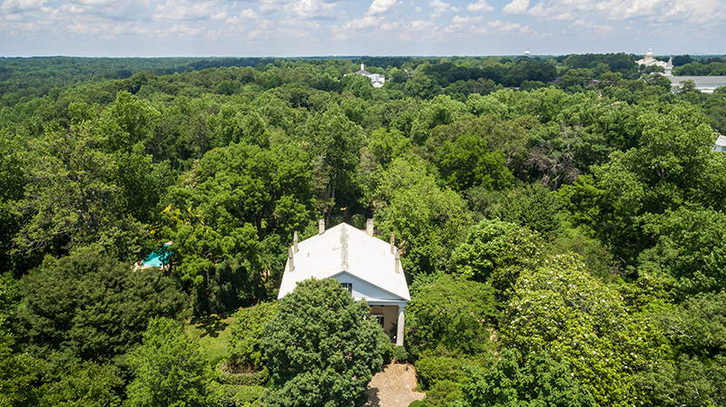
Figure 1: With its minimal tree coverage and its orientation, Mimosa Hall is ideally situated for solar power.

The World is Recognizing the Value of Solar Power
Activists, politicians, and even celebrities are recognizing the value of alternative energy. In 1979, President Jimmy Carter delivered a groundbreaking address to Congress on the White House’s new policy “to hasten the day when solar and renewable sources of energy become our primary energy resources.” He cites the rising cost of oil, the dangers caused by pollution, and the depletion of Earth’s oil supply, as some of his primary reasons for supporting solar energy:
Energy from the sun is clean and safe. It will not pollute the air we breathe or the water we drink. It does not run the risk of an accident which may threaten the health or life of our citizens. There are no toxic wastes to cause disposal problems.
In his address, part of a dedication ceremony to the solar power water heaters installed on the White House, Carter observes that renewable, natural energy, is a logical return to pre-industrial environmental standards:
Much of the technology for applying the sun's power to everyday tasks has been in use for hundreds of years. There were windmills on our great plains long before there were high tension wires. There were factories in New England using waterpower long before the internal combustion engine was invented.
Read Carter’s full address here.
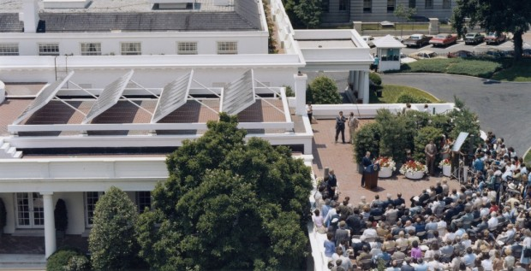
Figure 2: Solar panels on the White House, 1979. Image Credit: Jimmy Carter Presidential Library/NARA
Although Carter’s solar panels were removed from the White House by a later administration, they remained operable into the twenty-first century, as Carter predicted. We are excited that Mimosa Hall, as the oldest Net Zero building in the United States, will lead the way for other historic properties to return to the non-polluting roots described by President Carter without sacrificing today’s comforts.
In 2014, new solar panels were installed on the White House with the approval of President Barack Obama. Watch a video about the 2014 solar panels here. In a 2015 speech at the National Clean Energy Summit, President Obama described the growing interest in renewable energy in the twenty-first century:
America is making incredible progress on this issue. And that’s one of the reasons why I recently committed this country to getting 20 percent of our energy from renewables beyond hydroelectric power by 2030. And, by the way, when we do smart things in America, that wakes up the world. So Brazil’s President joined me for that announcement, committed her country to the same goal.
Similarly, President Obama drew attention to the growth of renewable energy within the U.S.:
The private sector is increasingly all in. Cities and states are increasingly doing their part. Just today, 15 cities from Seattle to Chicago to New York are joining 19 cities that have already pledged to reduce emissions and invest in climate resilience. Leaders in California are aiming to generate 50 percent of their electricity from renewables by 2030 -- 50 percent -- while cutting carbon pollution from oil by 50 percent.
Roswell is also a progressive community; the City of Roswell runs a Build Green Incentive Program and has been certified Gold by the Atlanta Regional Commission as a “Green Community leading the way to sustainable living.” Since 2009, Roswell has created numerous policies to eliminate waste, boost recycling, and increase energy efficiency. Roswell, like the cities named by President Obama, is leading the way for other American communities. Read President Obama’s full speech here.

Renewable Energy Sources and the Environment
Solar power has become an especially lauded renewable energy source because of its positive impact on the environment. Pollution caused by nonrenewable energy sources puts lives at risk, while solar energy helps to mitigate this damage to the environment. According to a Stanford University study published in June 2018, “A 100% WWS [wind, water, and sunlight] system is expected to reduce health effects significantly by reducing air pollution mortality from cardiovascular disease, respiratory illness, and complications from asthma.” The study observes that if major cities switch to 100% renewable energy sources, thousands of lives will already be saved by 2050.
Pollution caused by fossil fuels inflicts financial havoc, as well:
Damage due to global warming includes coastal flooding and real estate loss; agricultural loss; health issues from greater heat stress and stroke, urban and wildfire air pollution, influenza, malaria, and dengue fever; magnified drought, wildfires, water shortages, famine, and flooding; ocean acidification; and more severe weather.
Such disasters, if not rectified by cities switching to renewable energy, are projected to cost $393 billion per year in damage by 2050. Read the full Stanford University study here. 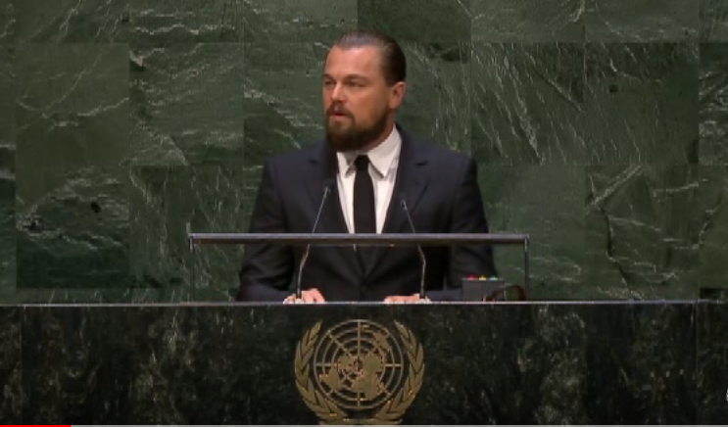
Figure 3: Leonardo DiCaprio speaks at the 2014 United Nations Climate Summit.
For these reasons, people are increasingly turning to renewable energy sources and particularly solar power. Actor Leonardo DiCaprio created the Leonardo DiCaprio Foundation in 1998 to help solve pressing environmental issues, including climate change, which he attributes largely to fossil fuels. The foundation donated $20 million to environmental causes in 2017. DiCaprio was appointed a United Nations Messenger of Peace and has inspired millions of fans with his speeches on the importance of pursuing renewable energy sources. Watch his address at the 2014 UN Climate Summit here.
A recent Solar Market Insight Report revealed that generation of solar power increased 13% in the first quarter of 2018 compared with the first quarter of 2017. Read the full report here. It is especially booming in California; thanks to the California Energy Commission’s standards, all new residential homes built in California require solar energy generation components. As Terry Tamminen of the Leonard DiCaprio Foundation points out, solar power saves the average Californian $80/month on energy bills.
We are looking forward to seeing Mimosa Hall & Gardens join this initiative with its solar roof. As the oldest Net Zero building in the country, Mimosa will set a new precedent for responsible historical preservation!

